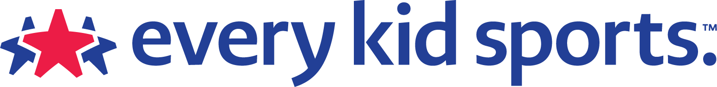
Financial assistance for sports activities for kids in the Pacific NW provided by Every Kid Sports (formerly Kids In The Game). Up to $150 available for after school sports registration fees. Families are eligible if they receive free/reduced lunch, SNAP, WIC or are in foster care or participating in Migrant Education Program.

The Pacific Northwest Pass
Pacific Northwest families whose children are qualified for free/reduced lunch programs are encouraged to apply for up to
$150 of after-school sports registration fees.
The Pacific Northwest Pass Program features a simple-to-use process for getting your child registered for sports.
Our goal is to provide families the resources to bring and keep activity in the lives of their kids.

How the PNW Pass Works:
In partnership with the Julia Love Pritt Foundation, KIDS in the GAME and PHIT America are providing funding to low-income families throughout the Pacific Northwest which includes Oregon, Washington, Idaho, Montana, Wyoming and Alaska. The Pass is available to kids 4 -18 years old participating in recreational after-school sports programs.
Youths, parents, advocates, counselors, and specialists can apply online to KIDS in the GAME for “sportsidies.” We are providing financial assistance to assist with registration fees, for your kids’ recreational activities of choice. Checks will be made out to the organizations offering the activities. Families present these payments at registration. Grants are available to low-income families living in Alaska, Idaho, Montana, Oregon, Washington and Wyoming.
Families must present at the time of registration one of the following documents verifying their low-income status:
Free / Reduced Lunch verification letter
SNAP
WIC
Foster child paperwork
COE for Migrant Education Programs

